**DID YOU JUST TOUCH**

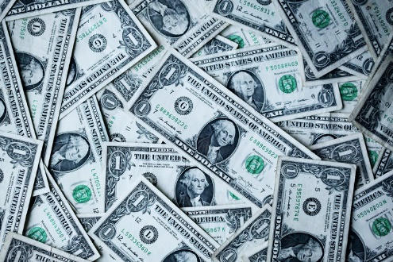

**CASH?**

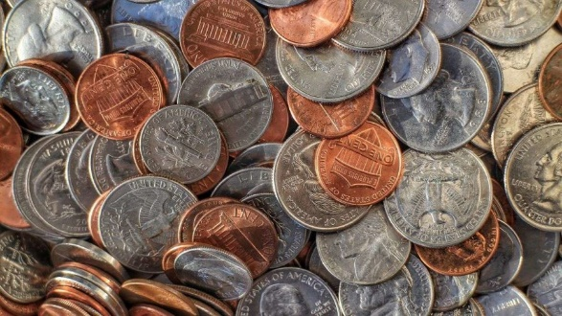

**COINS?**

**DID YOU KNOW**

* **People touch money after licking their fingers or touching their genitalia?**
* **One study found 94% of U.S. currency to be contaminated with bacteria?**
* **Your cash could be contaminated with E. Coli, and salmonella?**
* **Scientists from NYU have found over 3000 types of bacteria on one-dollar bills?**
* **The bacteria on your cash could be the cause of your acne, ulcers, or even food poisoning?**
* **Your money could have anthrax?6**

**ALL MONEY IS DIRTY.**

***WASH* *YOUR HANDS.***